

**Formula Imperial ESF 1**

**INTRODUCTION**

Part 1 of the Formula Imperial ESF is intended to help teams solidify those design decisions that need to be made early in the program. This will also help the technical reviewers identify possible areas of concern early.

Many of the fields in this form will also be found in the ESF Part 2 and the information in those fields will need to be reentered when the ESF Part 2 is submitted.

It is expected that some of the information will change during the development of the vehicle. Teams should not feel “locked in” by the data provided here, however data entered in the ESF Part 2 will be considered final.

**The information in this form will also be provided to the design judges, so teams may expect questions during the design event relating to why a particular aspect of the vehicle was changed during development.**

**INSTRUCTIONS AND REQUIREMENTS**

.

1. Enter the information requested as accurately as possible. If a particular portion of the design has not been finalized, give a short description of the options being considered.
2. Please submit any questions, corrections and suggestions for improvement to: [formulaimperial@imperialsociety.in](mailto:formulaimperial@imperialsociety.in)
3. When completed, this document must be submitted in Microsoft Word format (“docx”) – NOT PDF – at [formulaimperial@imperialsociety.in](mailto:formulaimperial@imperialsociety.in)

**Table of Contents**

Section 1 Vehicle Overview 2

Section 2 Frame and Body 3

Section 3 Engine 4

3.1 Engine Data 4

3.2 Architecture 4

Section 4 Electrical System Overview 5

4.1 Block Diagram 5

4.2 Vehicle Layout 5

4.3 Electrical System Parameters 6

4.4 Firewall(s) 6

Section 5 Tractive System 7

5.1 Motor(s) 7

5.2 Motor Controller 7

Section 6 Accumulator System 8

6.1 Accumulator Pack 8

6.2 Cell Description - Batteries 8

6.3 Cell Configuration 9

6.4 Accumulator Management System (AMS) 10

6.5 Charging 10

6.6 Accumulator Container/Housing 11

6.7 Shutdown Circuit 11

6.8 IMD 11

Section 7 GLV System 13

7.1 GLV System Data 13

List of Figures

Figure 1- Electrical System Block Diagram 5

Figure 2 - Locations of major TS components 5

Figure 3 – Safety Shutdown Circuit Schematic 11

List of Tables

Table 1 - Engine Data 4

Table 2 - General Electrical System Parameters 6

Table 3 - Motor Specifications 7

Table 4 - Motor Controller Specifications 7

Table 5 - Main Accumulator Parameters 8

Table 6 - Main Cell Specification 9

Table 7 - Capacitor Specifications 9

Table 8 - AMS Data 10

Table 9 - Accumulator Charging Data 10

Table 10 - IMD parameters 12

Table 11 - GLV Data 13

# TITLE PAGE

*Please include team logo, car picture, team picture, etc.*



|  |  |
| --- | --- |
| University Name: | VELLORE INSTITUTE OF TECHNOLOGY, VELLORE |
| Team Name: | TEAM UTTEJIT |
| Car Number: | H690 |

Main Team Contact for ESF related questions:

|  |  |
| --- | --- |
| Name: | SHIVAM DUBEY |
| e-mail: | shivam.dubey2018@vitstudent.ac.in |

# Vehicle Overview

Check the appropriate boxes:

**Vehicle is**

New (built on an entirely new frame)

New, but built on a pre-existing frame (FSAE, FS, FI electric-only, etc.)

Updated from a previous year vehicle

**Architecture**

Hybrid

Electric-only

**Drive**

Front wheel

Rear wheel

All-wheel

**Regenerative braking**

Front wheels

Rear wheels

All wheels

None

# Frame and Body

List the materials used and the construction methodology for the frame and body. Include CAD drawings, photos or sketches as appropriate.

**Frame**

Materials: **AISI 4130 alloy steel**

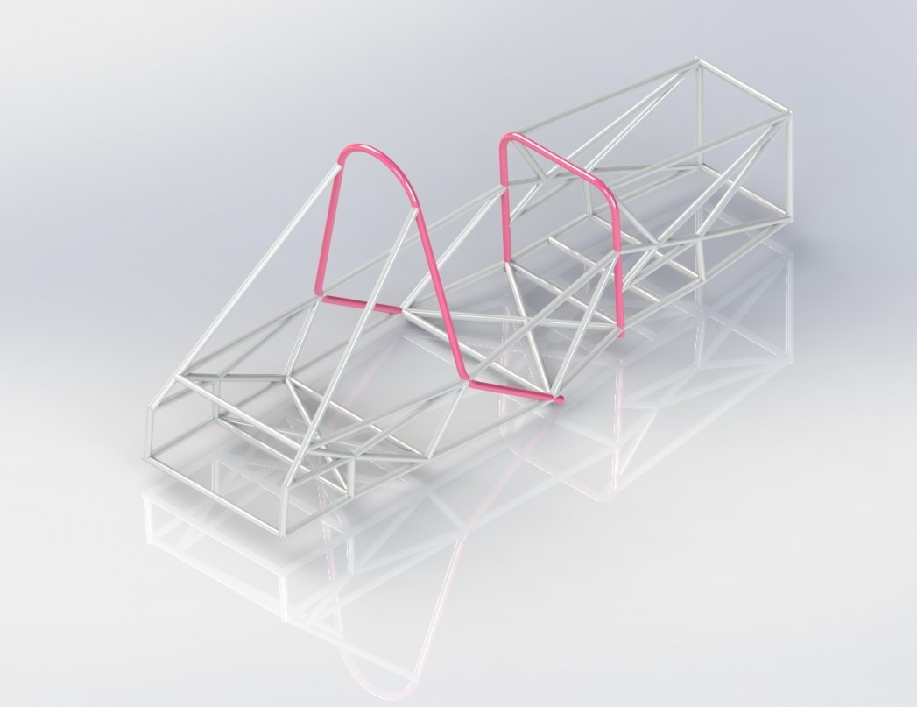

Joining Methods and Construction**: With TIG Welding**

**Body**

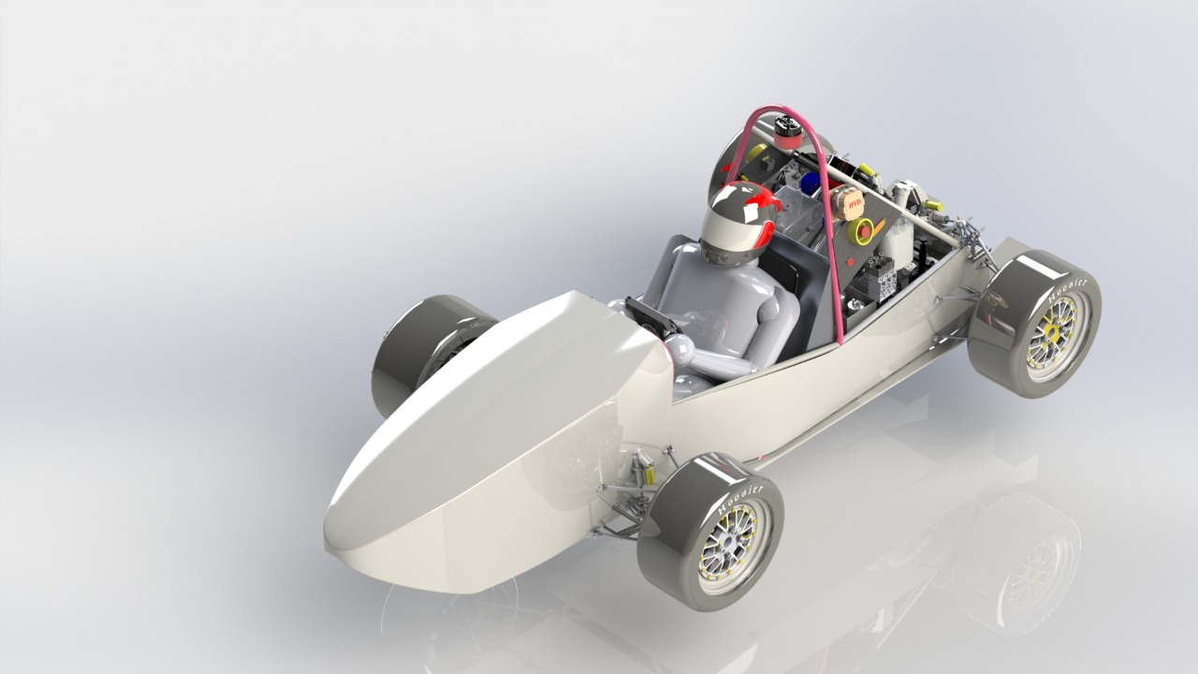

Vehicle complete body view

Materials: **Carbon Fiber Reinforced Plastic**

Construction:

* Molding
* Vacuum Bagging
* Compression Molding
* Filament Winding

# Engine

*Skip this section if electric-only*

## Engine Data

|  |  |
| --- | --- |
| Manufacturer | KTM |
| Model Number | KTM DUKE 200cc |
| Modified? | Yes No |
| Number of Cylinders | 1 |
| Bore | 72mm |
| Stroke | 49mm |
| Displacement | 199.5cc |
| Fuel type | Gasoline E-85 |
| Max. Power | 11.38kW @ 8600 RPM |
| Max. Torque | 14.11N⋅m @ 6600 RPM |
| Weight (Approximate) | 37kg |

Table 1 - Engine Data

## Architecture

Describe how the outputs from the I.C. engine and electric drive systems are merged:

Two way parallel hybrid, merged through a Planetary Gear Set coupler.In coupler we get the freedom of using both our engine as well as motor in it’s most efficient mode ,hence improving and making the ride more selective and economic. For this purpose we are using planetary gear set with managing inputs from motor to sun gear, from engine to ring gear and getting the desire output from planetary gear.

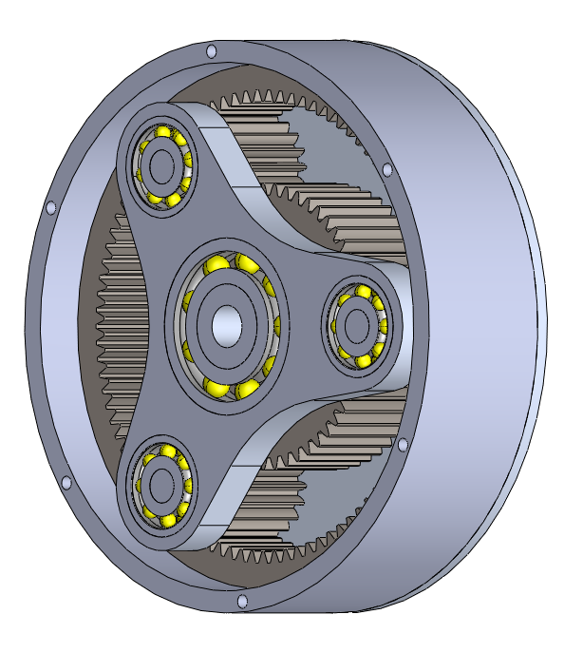

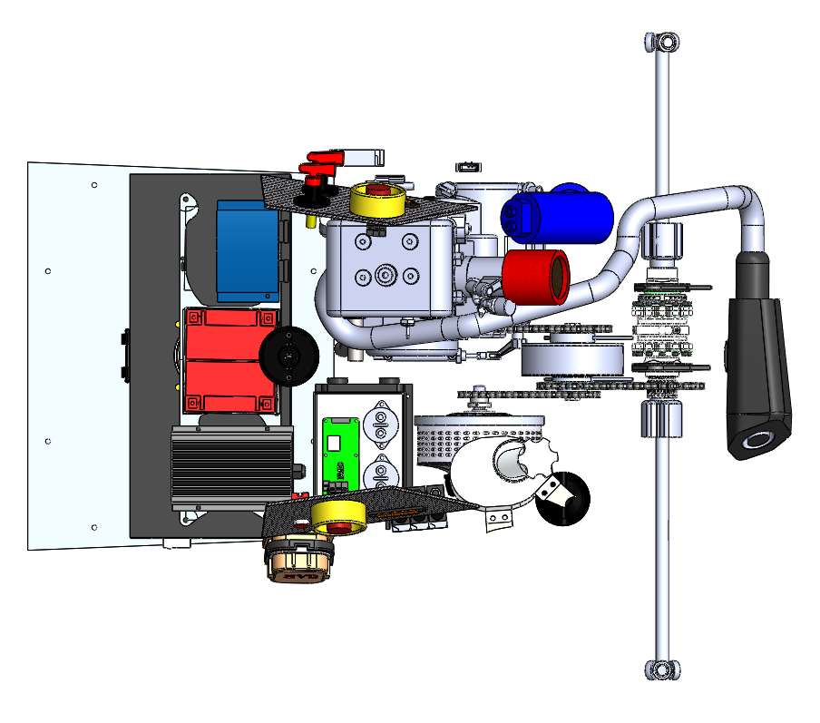

# Electrical System Overview

## Block Diagram

Figure 1 – include an electrical system block diagram showing all major parts associated with the tractive-system. (Not detailed wiring).

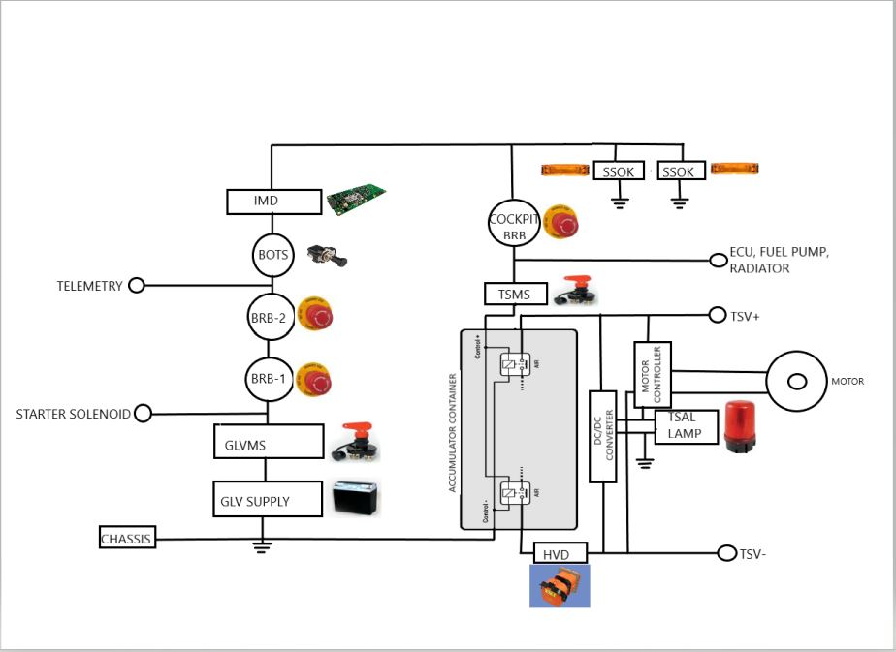

Figure-2 Electrical System Block Diagram

## Vehicle Layout

Figure 2 – include a diagram showing the location of all major parts associated with the tractive-system superimposed on a top view of the vehicle.

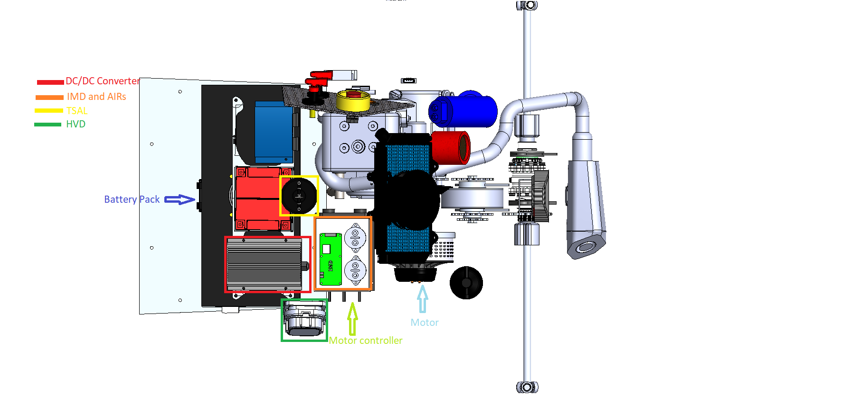

Replace this with your own figure

Figure 3 - Locations of major TS components

## Electrical System Parameters

Fill out the following table:

|  |  |
| --- | --- |
| Nominal Tractive System Voltage (TSV) | 48VDC |
| Max. TSV (typically this is during charging) | 54.6VDC |
| Control System voltage (GLV) | 2*12VDC |
| Total Accumulator capacity | 3744Wh |
| Accumulator type (Lead-acid, Li-Ion, NiMH) | Li-Ion |
| Number of electric motors. (Total) | 1 |
| Are wheel motors used? | Yes No |

Table 2 - General Electrical System Parameters

## Firewall(s)

**Description/materials**

Describe the concept, layer structure and the materials used for the firewalls.

The firewall in the vehicle isolates the driver from all the TS components, Engine, Motor, mechanical part, Accumulator pack and also from heat dissipated by the engine. Thus, protects the driver from any mishaps. Firewall is made of Aluminium of 2 mm thickness covered with Nomex 410 Insulating Barrier.

**Position in car**

Provide CAD-rendering or sketches showing the planned location of the firewall(s).

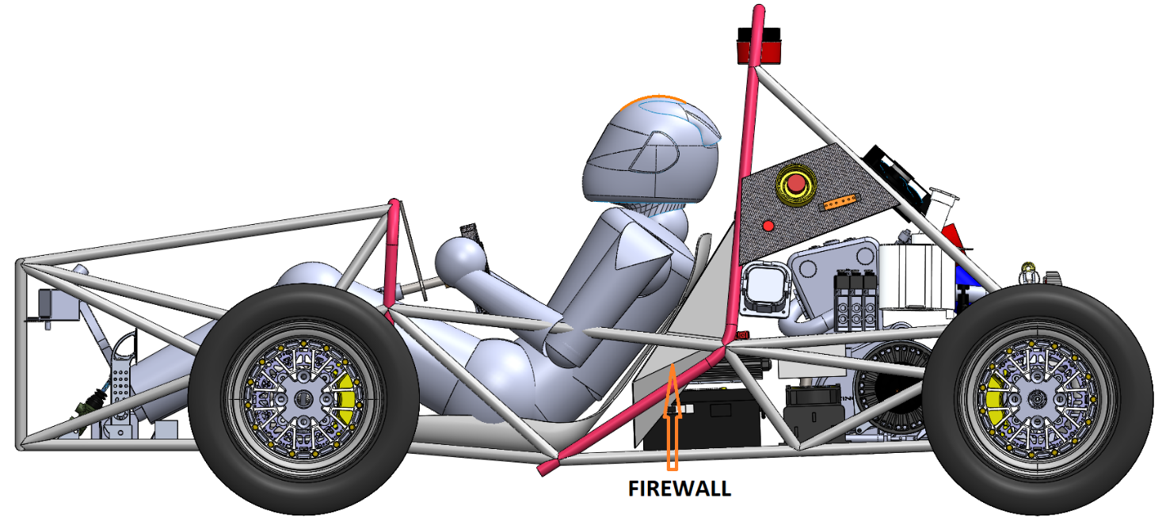

# Tractive System

## Motor(s)

Add additional tables if multiple motor types are used

|  |  |
| --- | --- |
| Manufacturer | Saeitta (Saeitta Motors) |
| Model Number | 119R |
| Motor Type (PM, Induction, DC Brush…) | Axial Flux DC Motor |
| Nominal motor voltage (Vrms l-l or Vdc) | 72VDC |
| Nominal / Peak motor current (A or A/phase) | Nom: 200A Peak: 400A |
| Nominal / Peak motor power | Nom: 13.2kW Peak:25.2kW |

Table 3 - Motor Specifications

## Motor Controller

|  |  |
| --- | --- |
| Manufacturer | Kelly Controls |
| Model Number | KDH12601E |
| Maximum Input voltage: | 18-90VDc (from Battery) |
| Nominal Input Current: | 600A |
| Output voltage (Vac l-l or Vdc) | Max 90VDc |
| Isolation voltage rating between GLV and TS connections | 90VDc |
| Is motor controller accelerator input isolated from TSV? | Yes No |

Table 4 - Motor Controller Specifications

# Accumulator System

## Accumulator Pack

Provide a narrative design of the accumulator system and complete the following tables.

The cells are arranged in 30 cells in parallel and 13 cells in series.

|  |  |
| --- | --- |
| Maximum Voltage (during charging): | 54.6VDC |
| Nominal Voltage: | 48VDC |
| Total number of cells: | 390 |
| Are packs commercially or team constructed? | Commercial Team |
| Total Capacity: | 3.7kWh |
| Maximum Segment Capacity: | MJ |

Table 5 - Main Accumulator Parameters

## Cell Description - Batteries

|  |  |
| --- | --- |
| Cell Manufacturer | Tech Imperial |
| Model Number | Av-13S30P100A18112019078 |
| Cell type (prismatic, cylindrical, pouch, etc.) | cylindrical |
| Are these pouch cells | Yes No |
| Cell nominal capacity: | 2.6Ah |
| Discharge rate for nominal capacity (e.g. 1C, 2C etc.) | 3C |
| Maximum Voltage: | 4.25V |
| Nominal Voltage: | 3.7V |
| Minimum Voltage: | 2V |
| Maximum Cell Temperature (charging) | 125°C |
| Maximum Cell Temperature (discharging) | 85°C |
| Cell chemistry: | Li-Ion |

Table 6 - Main Cell Specification

## Cell Configuration

Describe configuration: e.g., *N* cells in parallel then *M* packs in series, or *N* cells in series then *M* strings in series.

30 cells in parallel and 13 in series, 13S30P

*Note: Teams those who are manufacturing their own accumulator need to provide safety certificate and other documents related to the same.*

## Accumulator Management System (AMS)

|  |  |
| --- | --- |
| AMS Manufacturer | Tech Imperial |
| Model Number | BEST_13S100A |
| Number of AMSs | 1 |
| Upper Cell Voltage Trip | 4.25V |
| Lower Cell Voltage Trip | 2.5V |
| Temperature Trip | 85°C |

Table 8 - AMS Data

## Charging

|  |  |
| --- | --- |
| Charger Manufacturer | Nanya |
| Model Number |  |
| Maximum Charging Power: | 1.0075kW |
| GLV/TS isolation location:  (i.e. cell boards, main unit, etc.) | fuse |
| Certification? | Yes No |
| Maximum Charging Voltage: | 65V |
| Maximum Charging Current: | 15.5A |
| Input Voltage: | 185-265VAC |
| Input Current: | 6 A |

Table 9 - Accumulator Charging Data

## Accumulator Container/Housing

Describe the design of the accumulator container. Include the housing material specifications and construction methods.

The cells of the accumulator are stack in 13S30P (13 in series and 30 in parallel). The battery pack container is made up of the Mild Steel and has the IP 67 Rating. For the insulation, manufacturer has used a PFA block.

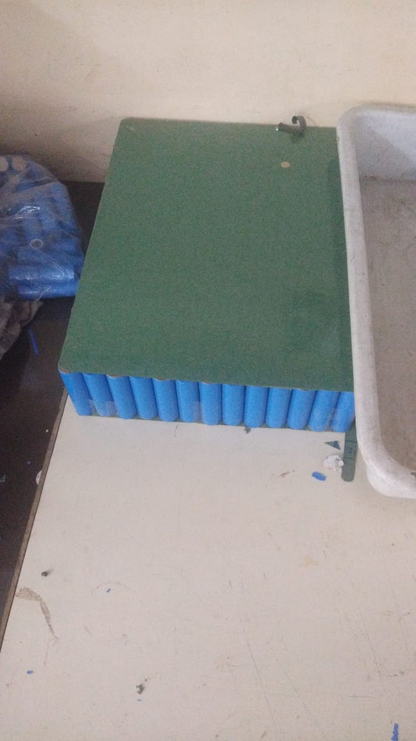

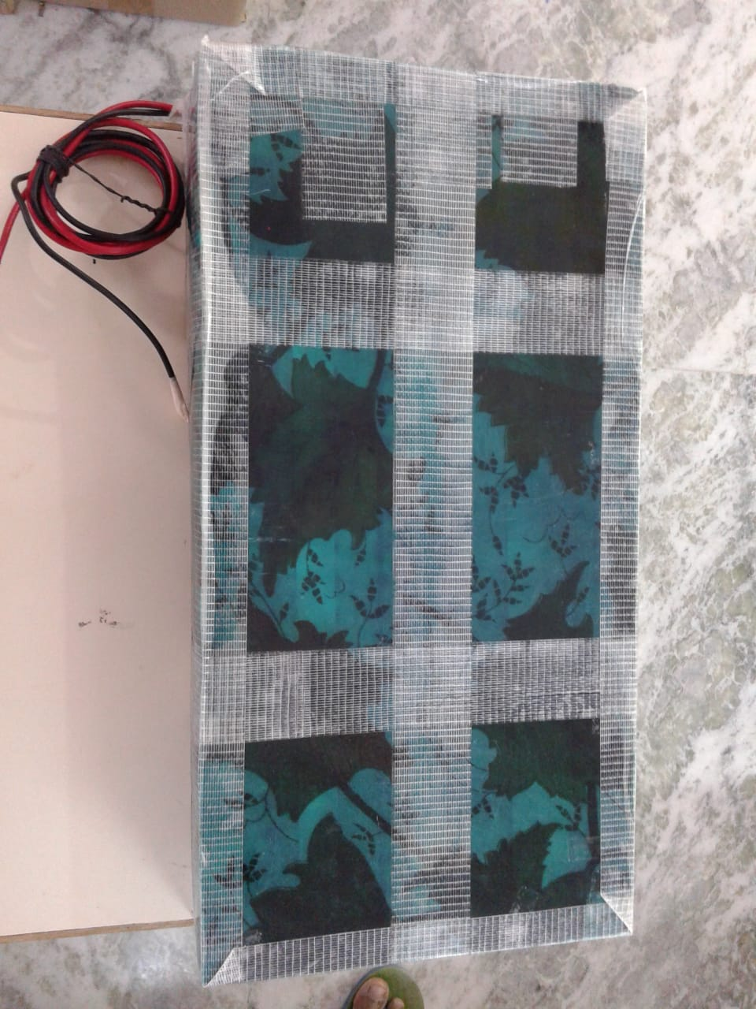

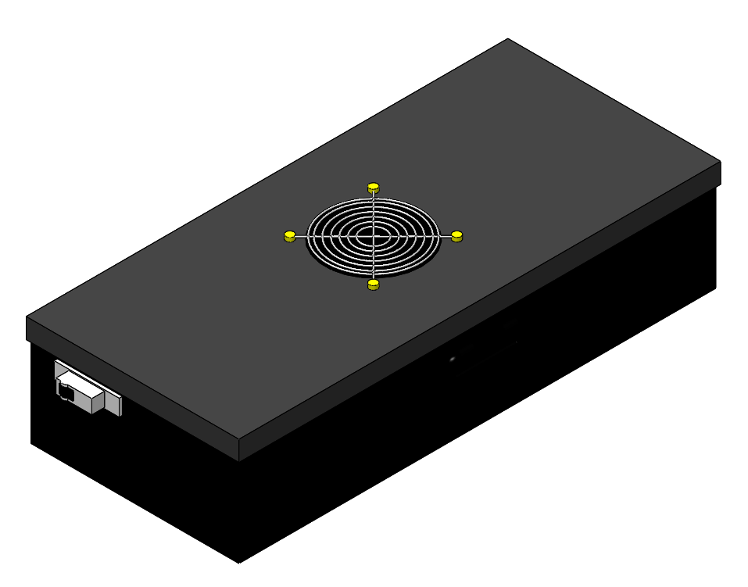



Where will the accumulators be located?

Behind the driver seat after enclosed by firewall

## Shutdown Circuit

Include a schematic of the shutdown circuit for your vehicle including all major components in the loop.

***Note:*** *The design of the shutdown circuit and team members understanding of how it works is extremely important. Take the time to be sure it is right.*

Figure 4 – Safety Shutdown Circuit Schematic

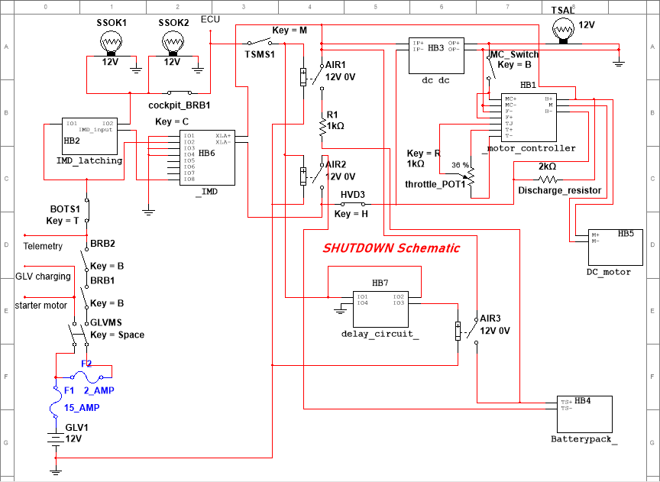

## IMD

Describe the IMD used and complete the following table:

The IMD is used for monitoring the insulation level in the vehicle. It monitors the insulation in GLV system as well the high voltage Tractive system. On detecting fault, it lights an IMD fault indicator LED.

|  |  |
| --- | --- |
| Manufacturer | BENDER |
| Model Number | ISOMETER IR155-3204 |
| Set response value: | 100kΩ (2083.33 Ω/Volt) |

Table 10 - IMD parameters

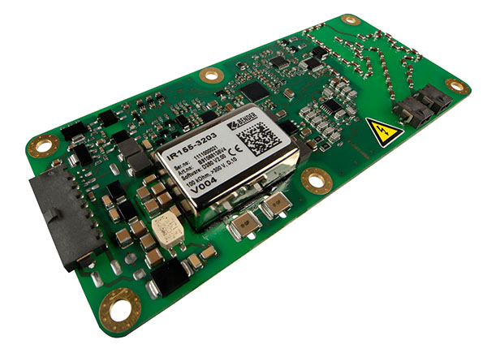

# GLV System

## GLV System Data

Provide a brief description of the GLV system and complete the following table.

GLV system consists of two 12V Exide Lead acid batteries. These batteries are used to power the shutdown system which contains the GLV master switch, Side mounted BRBs, BOT and IMD.

It also powers the ECU, Radiator and Fuel pump.

|  |  |
| --- | --- |
| GLV System Voltage | 2*12V |
| GLV Main Fuse Rating | 12A |
| GLV Accumulator type | Lead acid battery |
| How is the GLV storage recharged? | Engine alternator and external battery charger both |

Table 11 - GLV Data

